Design Rationale

This is for Game Iteration 2 of the simple tile map game by Devlan McKenzie

# Introduction

This paper will discuss the reasons behind the creation of the second iteration of the game and will cover the methods used during its creation. This will make reference to the previous design rationale used for game iteration 1. This is because this iteration focused on the creation of content based on audience and play tester feedback. In addition to this the game was polished in preparation for the final submission.

# Question

Can the processes discovered in the previous iteration be used to create content based on the audience, aesthetics and intentions of the game. In addition to this the play tester feedback gathered in the previous iteration revealed some issues in the game; can these issues be addressed using these processes?

# Process

Evaluation of the questions above reveals that all required enhancements and changes identified in play testing and feedback should be possible using the processes in the previous iteration and applying them to create content to further the intentions of the game. The feedback regarding future enhancements were evaluated, considered and that will be actioned will include a stronger enemy, such as an ogre or troll as well as an obvious motivator for the player to move the character.

The main issues identified previously were the need for gaps to better allow the goblin swarm to chase the player and the correction of the colliders. These were approached through the implementation of the Unity Tile Map system which allowed for a complete redesign of the map which addressed the gaps issue.

The first thing to note are the processes discovered previously which are the use of creativity and iterative design in art assets, secondly the target audience needs to be defined to warrant the basic art approach and simplicity of the game.

The audience was defined in the previous iteration design rationale and states that the game`s audience is between the age of 7 and 10 and are new to games. The content to be created thus needs to be simple so as to not overwhelm the younger newer players and appeal to that age bracket. This thus warrants a simple game with simple art assets.

Having implemented the above enhancements and content identified the existing code and design proved flexible and therefore no deviations from the original processes or intention were required.

The map has been reworked and now looks like this 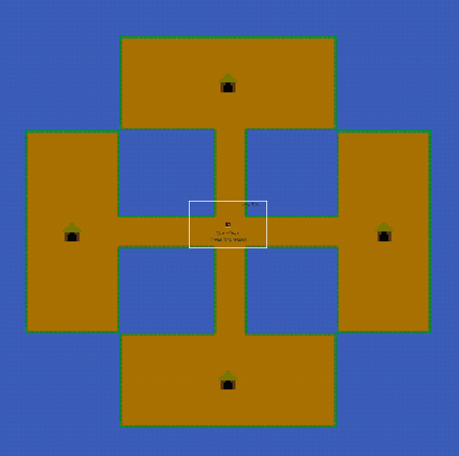

With the new design the map helps the player intuitively understand that there are 4 directions in which the player can move, these directions also solve the issue with the enemies getting stuck on the colliders. An additional change was made to the spawning of enemies; the enemies will only spawn from a hut if the player enters the immediate area around the hut and they are now limited in number. This limitation makes the game more approachable for younger newer players whilst introducing the concept of fight mechanics.

The changes allow the player to learn how to move around and attack in the safety of the passages, which further addresses the audience. Once the player learns how to move and fight they are intuitively encouraged to explore the world in the 4 directions. This allows the player to find the huts and clear that area, once an area is clear the player will become bored and explore the remaining passages. This provided motivation to move the character and ultimately fixed the enemies getting stuck issue.

The colliders of the map were reworked and implemented custom physics shapes which fixed the other issue with the colliders.

The same methods of creativity and iterative design were used to create the new art assets like the huts, ogres and chest. The ogres have more health and are thus a new bigger and stronger enemy, addressing the play tester feedback. The chest if found by the player will end the game and indicate that the player has won the game. This spawns randomly in 1 of the 4 areas and furthers the reason to move the character.

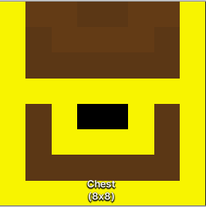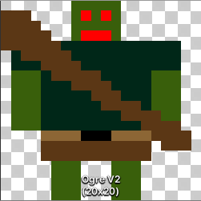

These are the assets implemented in the game, as is show above the chest is 8x8 and the ogre is 20x20. This allowed for more detail on the ogre while keep to the design and previous art style.

# Reflection

In conclusion the questions initially purposed were answer and have shown that you can apply the processes discovered to create more art in an effective manner, which is suitable for the audience and intentions of the game. Creating simple art that is uniform and used globally in the game creates a sense of self presence in the world which contributes towards player engagement. The simple art testifies to the aesthetics of the game and its intentions. The play tester feedback gathered previously was addressed in this iteration carrying through the processes found and described in previous game iterations.

# Future Plans

The addition of an ammunition system and additional attacks for the player to use as well as additional rewards to incentivise the player for game replay ability . Should this iteration be successful with the target audience it would be possible to create more game content using the methods described above in a timely and easy manner.

The addition of a high score system to introduce the concepts of competitive gaming and player improvement and satisfaction.